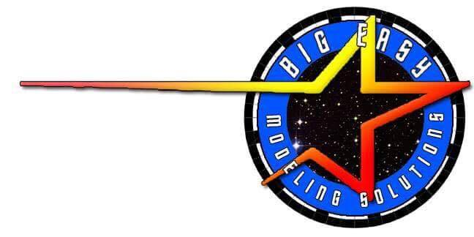

Big Easy Modeling Solutions Presents:
THE 1:500 ENTERPRISE
COMMANDER SERIES BOARD™

INTRODUCTION

Welcome to Big Easy Modeling’s lighting kit for the 1:500 Scale 2009 ENTERPRISE Starship model kit! In purchasing this kit and the effects board it is designed for, it can be assumed you’re building a very serious model requiring countless hours of work and planning and building and, most of all, FUN! And you’re likely looking for a very accurate representation of the beautiful Enterprise as she appeared on the original television show or, in some cases, your own version of the Grand Lady! We’re here to help you in the process so you can hopefully have less aggravation and more “WOW!” as you assemble this wonderful model.
This model kit is one of the most challenging and involved kits a modeler can face, especially when it comes to lighting, so make sure to follow all steps carefully and test all connections as you go.
The manual that follows is designed to help you easily install and connect all the lighting you need to make your model stand out. We’ve taken great consideration to make this kit as easy to install as possible, though some soldering will be necessary to get the results you want. Basic soldering skills are assumed with this kit, but if you need help or are not as experienced, feel free to contact us at Big Easy and we’ll do our best to assist you! We are confident that anyone can learn the skills necessary to make this lighting kit work for your build and we’ll help you in any way we can!
This manual is intended to be a usable reference for how the lighting kit is designed to work with the JAZZ MINI 2 2009 ENTERPRISE Commander Series effects board. It is not the ONLY way to do things and you, as the builder, are perfectly welcome to deviate and experiment with your own version of lighting the Big E. (ONLY recommended for experienced builders) However, we do caution against using other materials (such as LED’s, wires, resistors, etc) not included with this kit as you may damage the lights you’re using or, worse, the board itself. Big Easy Modeling Solutions claims NO RESPONSIBILITY for any damage caused by incorrectly using the supplied products or any damage caused by using materials other than those included in this kit.
*Note: using materials or components other than those included in this kit may void your warranty on your product!

HOW TO USE THIS GUIDE
This guide is presented in a format intended to be easy to decipher for the intermediate to advanced model builder who is passably familiar, at least, with lighting diagrams and electrical current flow. For the beginner, this kit is certainly usable! But you might want to take some time to gather some information and familiarize yourself with basic terminology and knowledge on electrical diagrams and current. This is especially true if you intend to deviate at all from the instructions for this kit.
The guide is presented in an “easy-to-read” format where the builder can simply solder the string of lights, as marked, and connect them to the color-coded terminal points, as marked. However, to ensure better connections, it is HIGHLY RECOMMENDED that the model builder solder the connecting wires together whenever possible! Terminal connections may not always be absolutely secure. Twisting the ends of wires together may also create some issues getting good connections. It is much more preferable to solder the end connections together whenever possible before inserting the wires into the corresponding terminal points. If connecting only a single wire, particularly wire wrapping wire (thin shielded wire) or magnet wire (thin coated wire), we recommend making a tiny “hook” by carefully curving the end of the wire back on itself to fit into the terminal. This helps to hold the wire in place so it doesn’t slip out of the screw lock.
Ultimately, it’s up to you, the builder, to choose how best to secure your wiring. We’ve made every possible attempt to make this process as simple as possible for builders of all levels. But you must choose the most secure method you prefer for your building style to ensure the best, lasting connection. We will make suggestions in the guide to help whenever possible/necessary.
There may be some times when a group of wires do not easily fit into a terminal, particularly on the main board. You may choose to make a “ponytail” by bringing together all the wires for that terminal and soldering them together or using a wire nut with a single short additional wire leading out which will connect to the terminal and supply current to all the connected wires. Instead of, say, 4 wires going into one terminal, you now have only the one.
A note on magnet wire and/or wire wrapping wire: Many of the solutions used for wiring LED’s in this kit involve the use of magnet wire or wire wrapping wire, both a form a thin, highly conductive wire used to reduce the visible profile of standard 24-28 gauge wire inside the model. Magnet wire is wonderful stuff! But, it’s also thin and potentially fragile. Pieces prewired with magnet wire (red and green in this kit) should be handled delicately so as not to damage the connections. Also note that, while all magnet wire pieces included have been prepared for connection, magnet wire can be a bit challenging to “strip” to prepare for proper connection. If your prewired LED’s with magnet wire don’t seem to be functioning, please double check to make sure the colored wire shielding has been stripped away at its connecting point and, if not, carefully use a #11 hobby blade to scrape away any shielding to expose wires as necessary.

Getting Started
So you’re ready to embark on your mission? Ok, the first step is to check the contents of the kit to make sure you have all included parts. There may be some modifications necessary to the model kit to accommodate lighting and wires you will need to make before completing installation. If so, you will need different tools to complete the various modifications. We recommend using a rotary tool such as a Dremel for the majority of them, but you should also need a drill or pin vise and a jeweler’s file.
Here is a useful chart for non-metric drill bit sizes to accommodate standard size LED’s if you need to change any mounting hole sizes:
1.8mm/2mm LED = 3/32” Drill bit
3mm LED = 1/8” Drill bit
5mm LED = 13/64” Drill bit
WE ALSO RECOMMEND MARKING THE INSIDE OF THE MODEL DESIGNATING WHERE YOU WILL BE INSTALLING LED’S.

Tools Needed:
- Jeweler’s standard (flat head) screwdriver.
- Low Temp hot glue gun. (optional to secure wires
- Wire snips and wire stripper
- Soldering iron with 60/40 rosin core solder

Soldering an LED
We realize not everyone has experience with electronics and, in particular, using a soldering iron. So the Big Easy team thought it would be a good idea to include a little basic tutorial here to make this process simple for you. With just a little bit of practice, you can solder an LED like the pros! Let’s check it out… (if you’re familiar with this technique, feel free to skip to the next section)
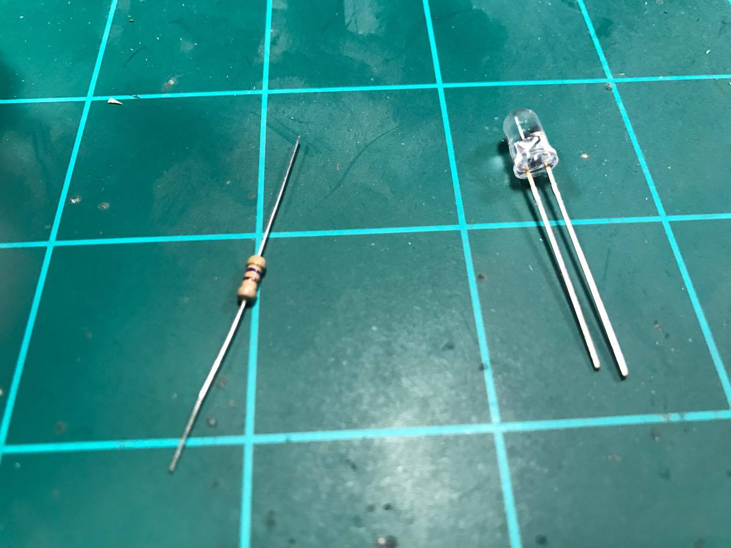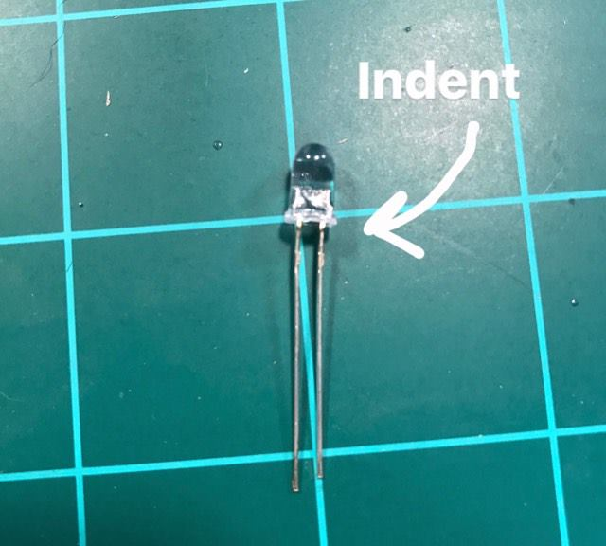
Obviously, the first thing you’ll need is an LED and a resistor. For this example, we’re using a 5mm Cool White LED and a standard 470 ohm resistor, like most of the resistors included in your kit. These resistors are designed for a 9V or 12V power source. Use a resistor calculator (or “Ohm’s Law”) for help in finding out which ohm rating you need for your power source if using something different. Your kit comes with appropriate resistors for the included power source. (Deflector/Impulse resistors may be different as those effects connect to a 5V terminal instead of the higher 9V or 12V)
Notice on your LED that each has a long metal lead and a shorter one. In almost all cases, the longer leg is positive and the shorter leg is negative. Also, on 3mm and 5mm LED’s, there is a noticeable indentation on the very low ring around the base of the bulb on the negative side. These will help you know which lead is which.
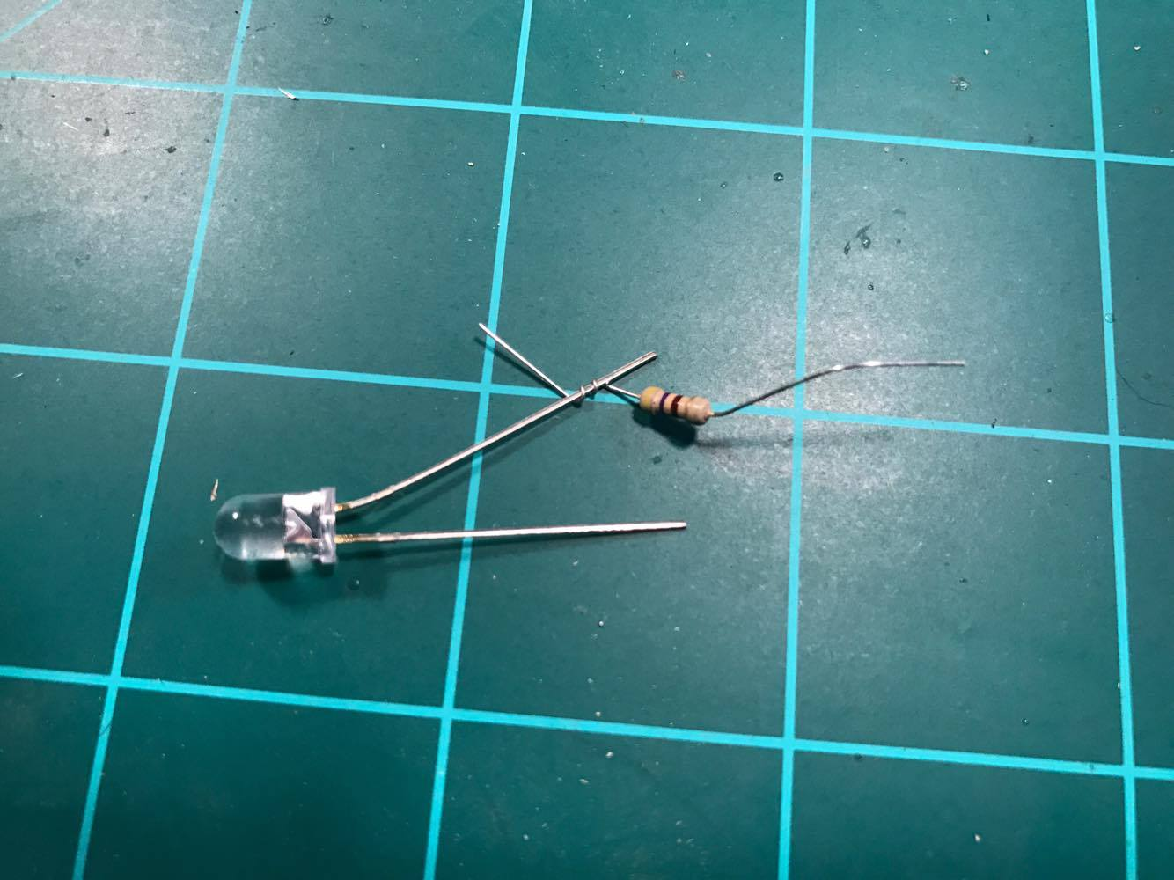
The first step is to wrap one metal lead (leg) of the resistor around one lead (leg) of the LED. NOTE: It does not matter which leg of the resistor goes on the LED leg as resistors are not polarized. Also NOTE: The resistor can be put onto EITHER leg of the LED. However, we strongly recommend always choosing the same one. (we tend to choose positive, as shown, because that’s how we were each taught, but it doesn’t matter) The reason to always use the same leg is so that, once you clip off any excess metal on the leg of the LED, you’ll still know positive from negative.
Soldering an LED (pg2) 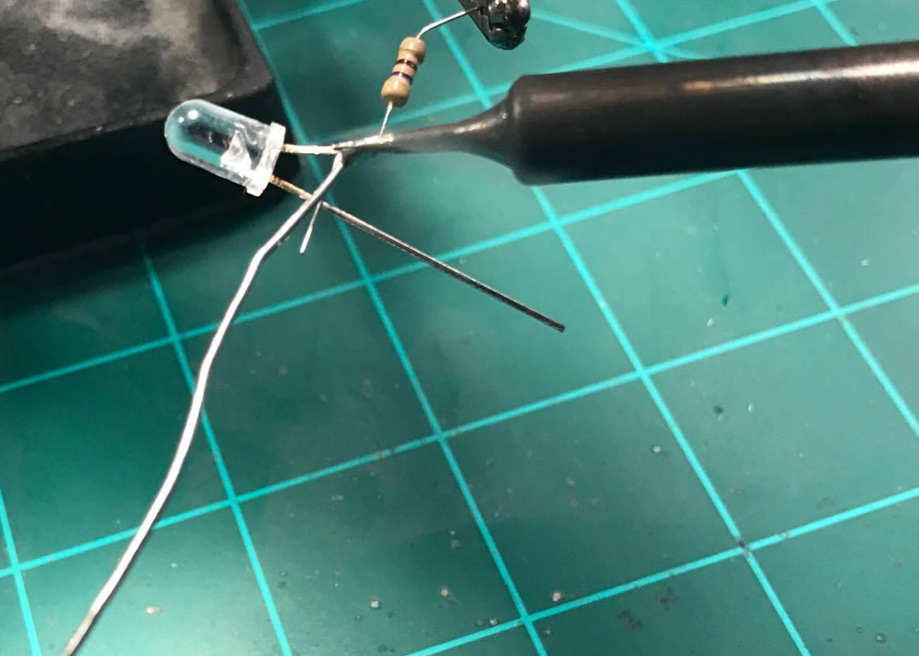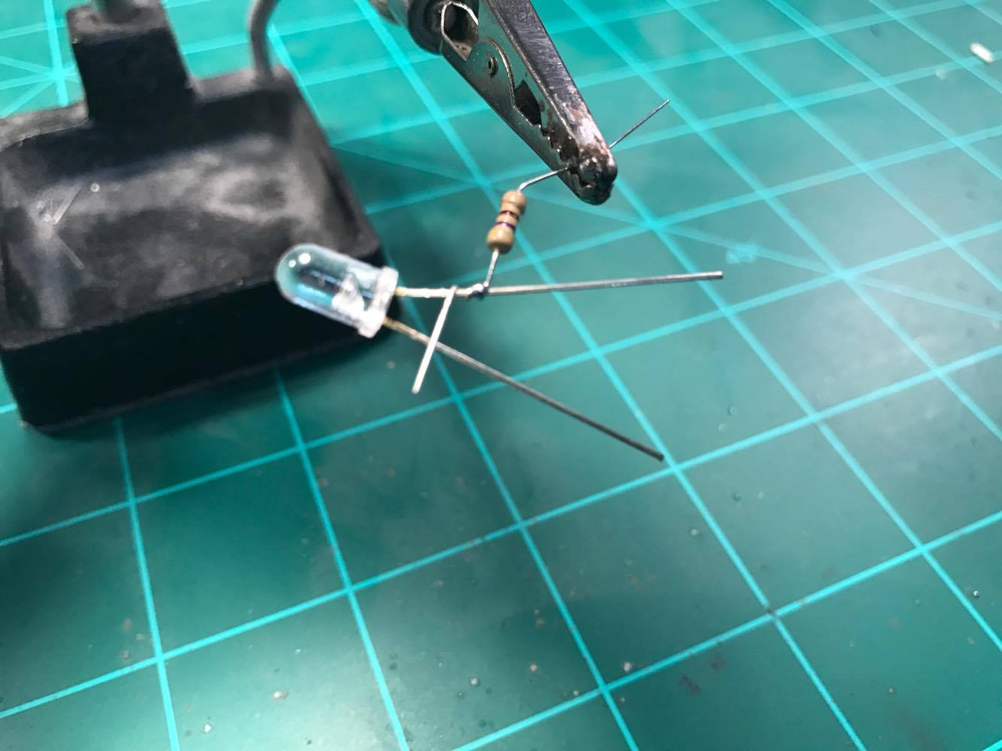
Next, slide the coiled resistor up the LED leg a bit and apply the solder by touching the iron and the tip of the solder coil to the wrapped resistor. For most LED’s, you should keep your soldering iron from 335˚C to 400˚C. Leave just enough solder to secure the two wire leads together. Then trim the excess wire from the LED leg and the resistor leg, making sure not to cut into the solder itself and separate the two again.
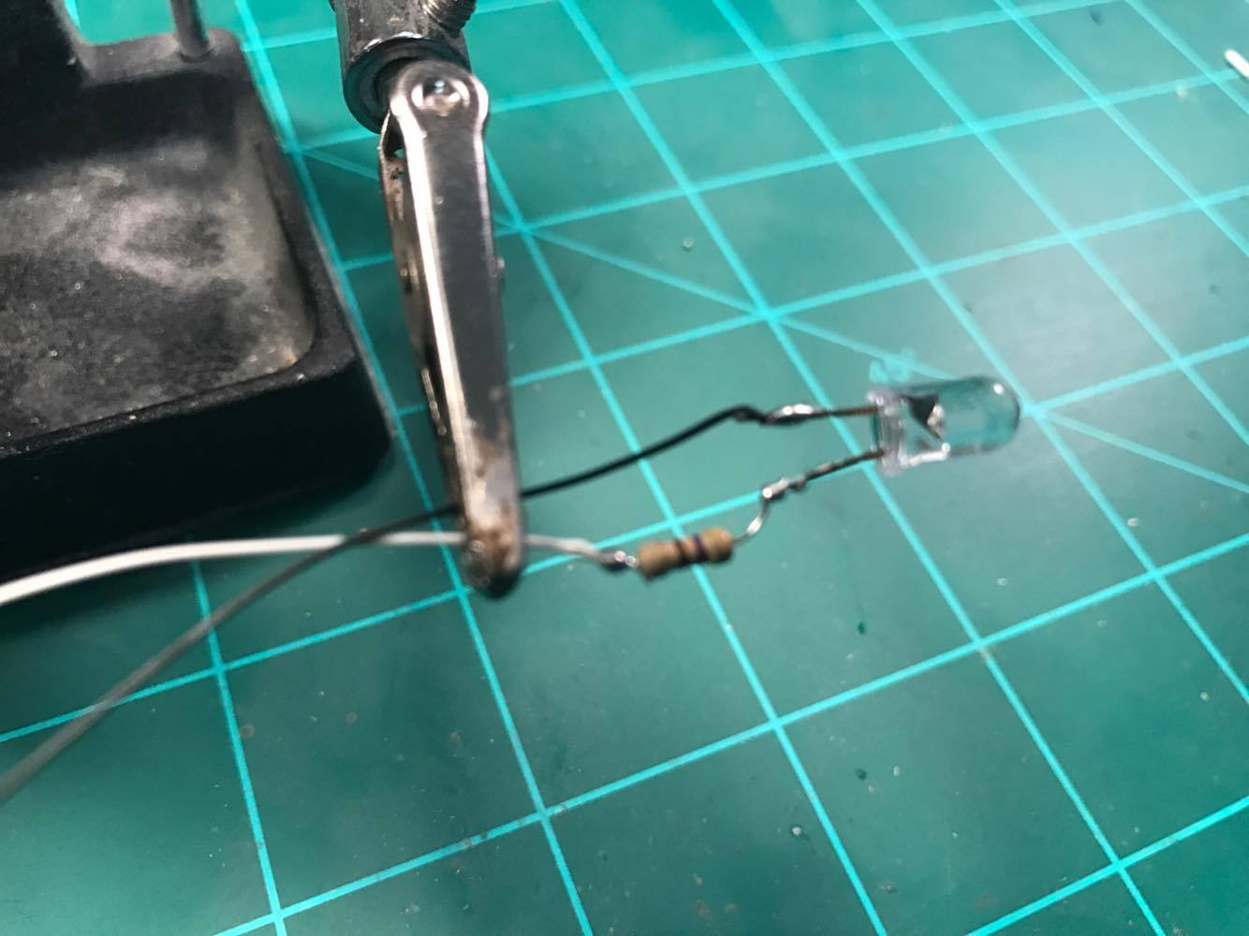
Next, repeat the same process with the wire by coiling about a cm of exposed (stripped) wire around the other end of the resistor and adding solder the same way. Then repeat this step for the negative wire and LED leg. (NOTE: you only need a resistor on one LED leg) Again, trim off any excess LED leg metal.
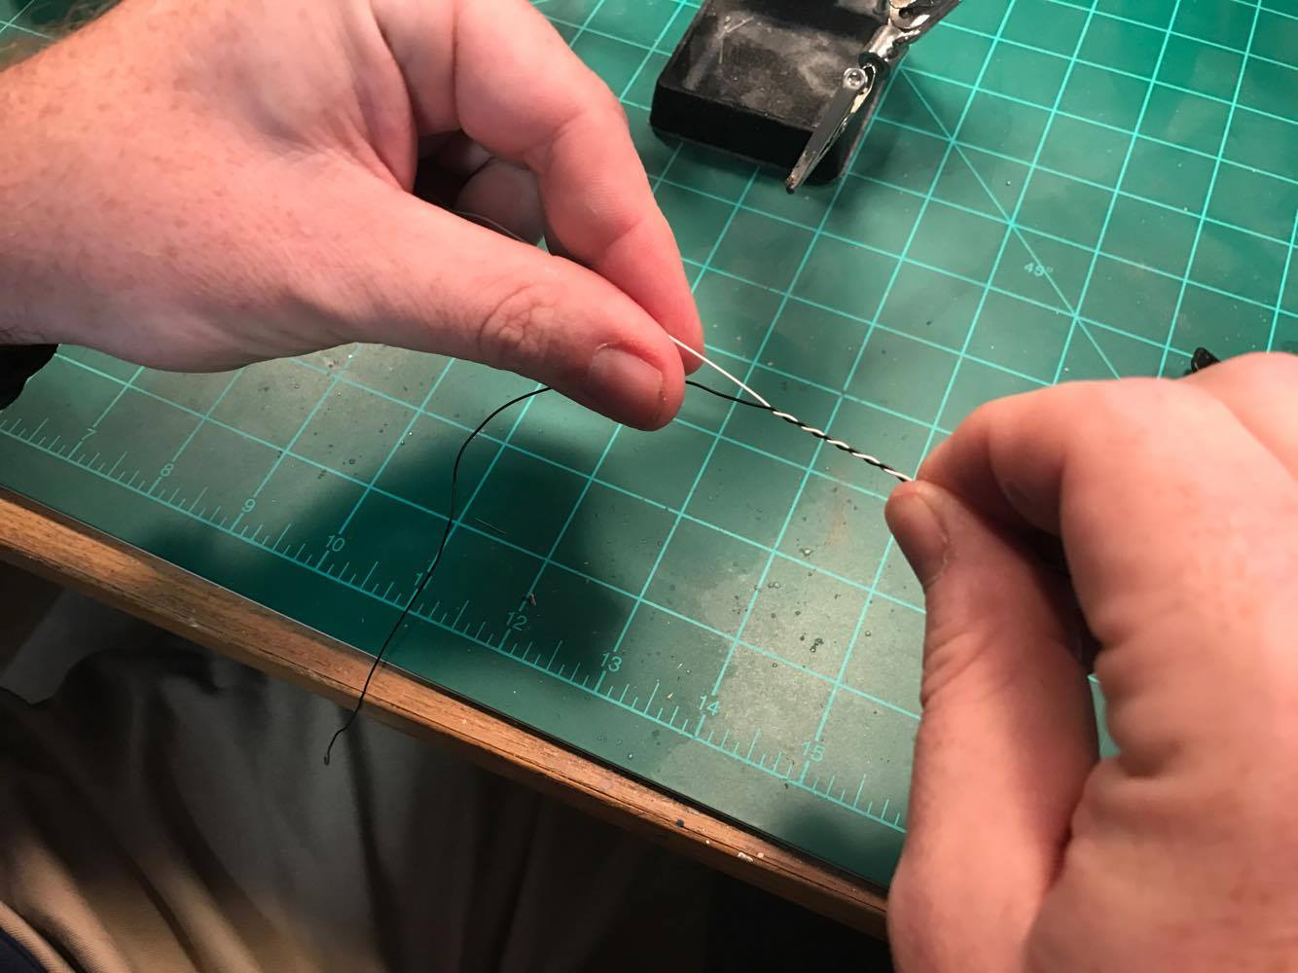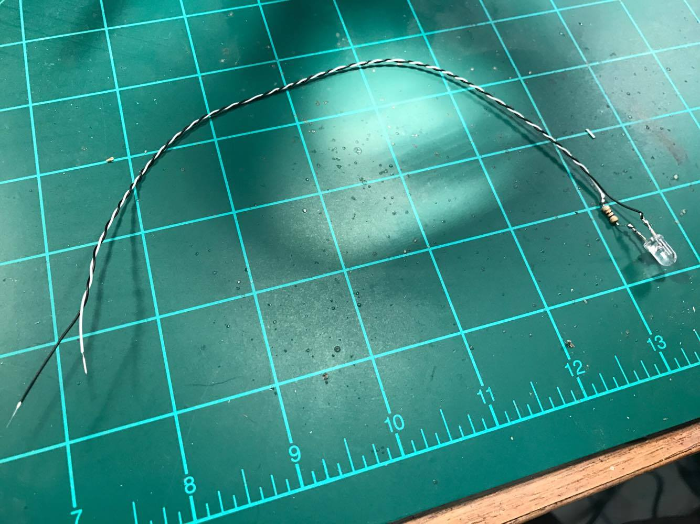
Finally, twist your attached wires tightly for a tidy finish, strip off a little shielding at the end of the wire, and you should be done! Test your LED by connecting the negative wire to negative on your power source and positive to the positive. (in this case, 9V-12V) If you see light, you’ve got it right!

Soldering an LED STRIP
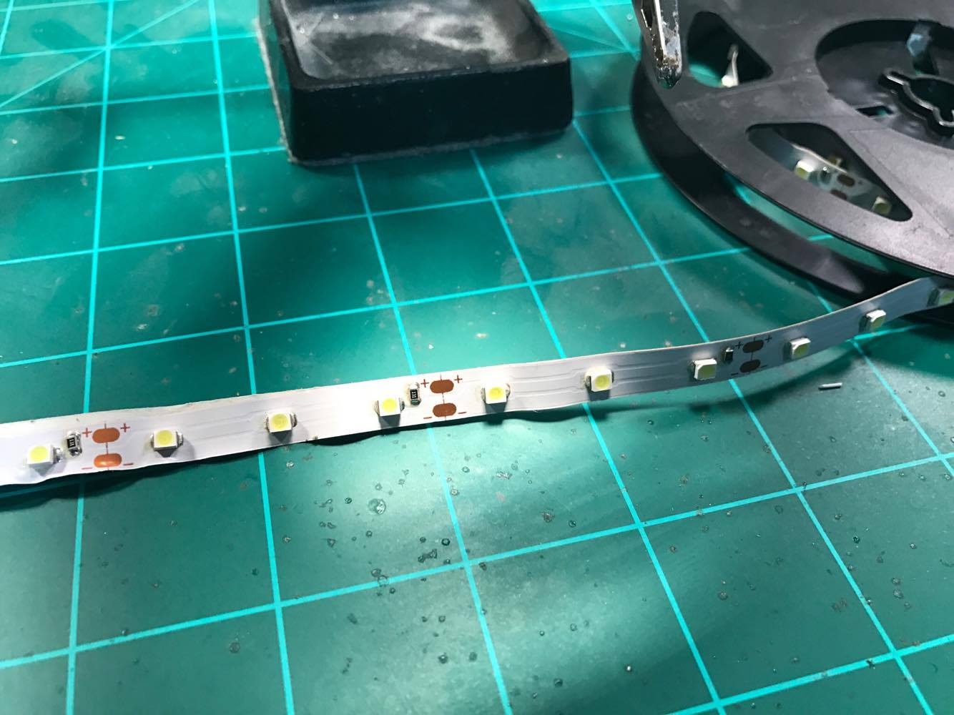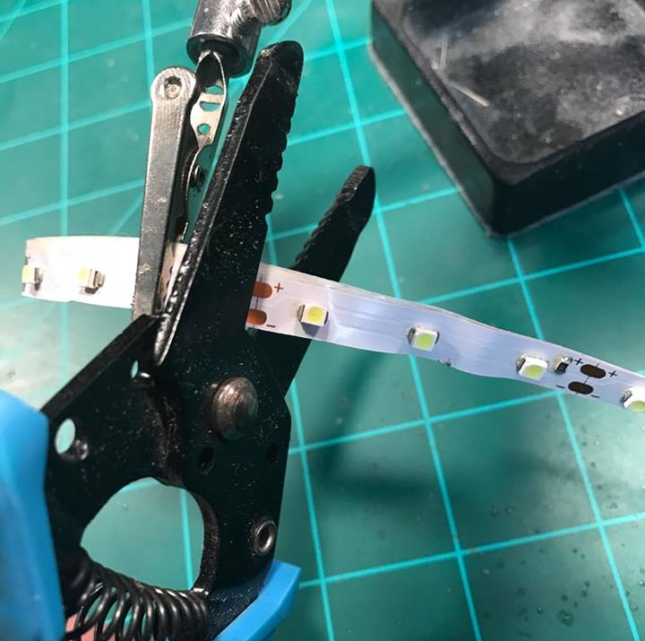
LED strips are convenient for several lighting needs! They are prewired with resistors to operate at 9V – 12V and may be cut every third LED into smaller strips. However, when cutting the LED strip, you must add solder to the connection points on the strip. This process is actually fairly simple and, since you don’t need a resistor for the strips themselves, it is a fast and easy process.
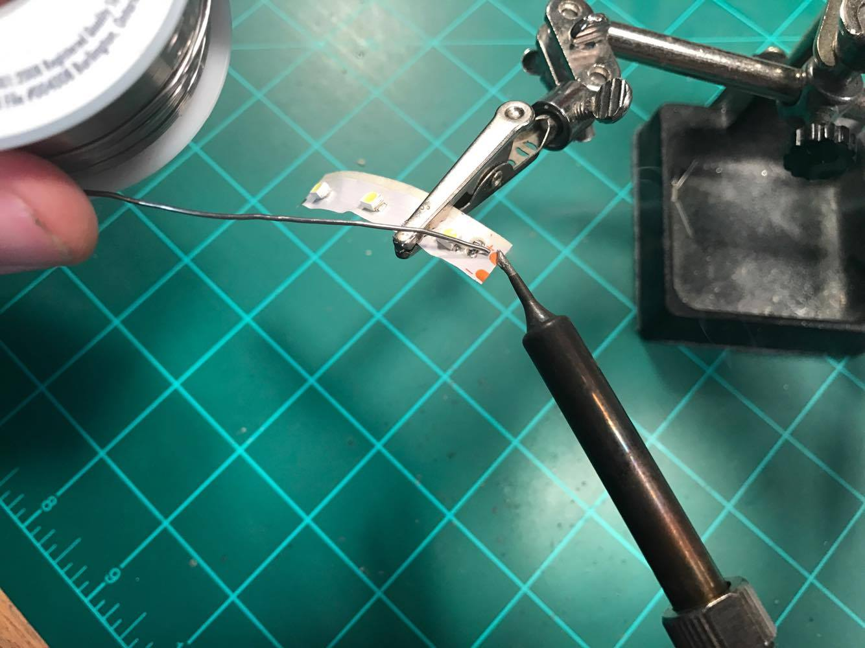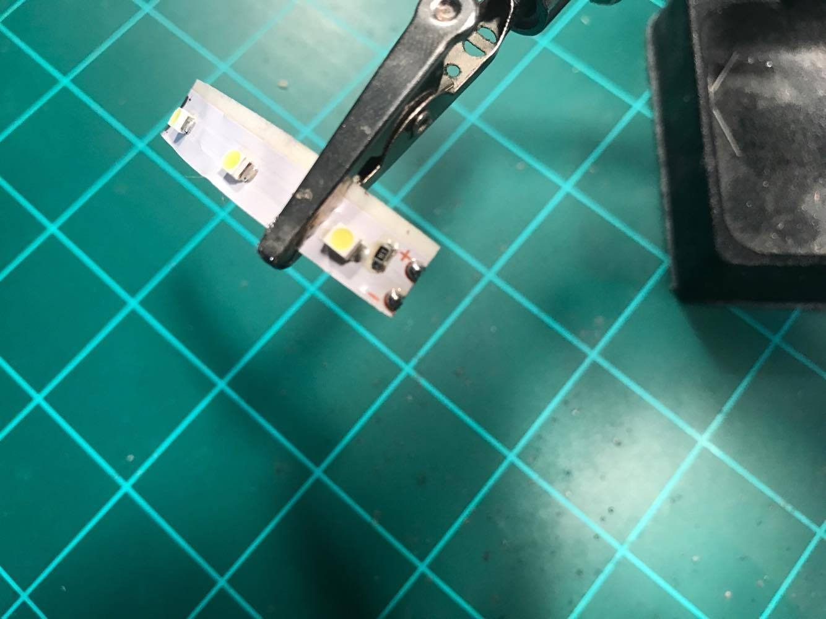
Notice that at the connection points, there is a positive side and a negative side. This is where we will add some solder before attaching the wire. (called “tinning” the solder point) Again, touch the solder coil and soldering tip together to the copper solder points, not just the iron tip with solder on it. “Drag” the melting solder from the solder coil onto the copper pads. You should have a small bead of solder at the point when finished.
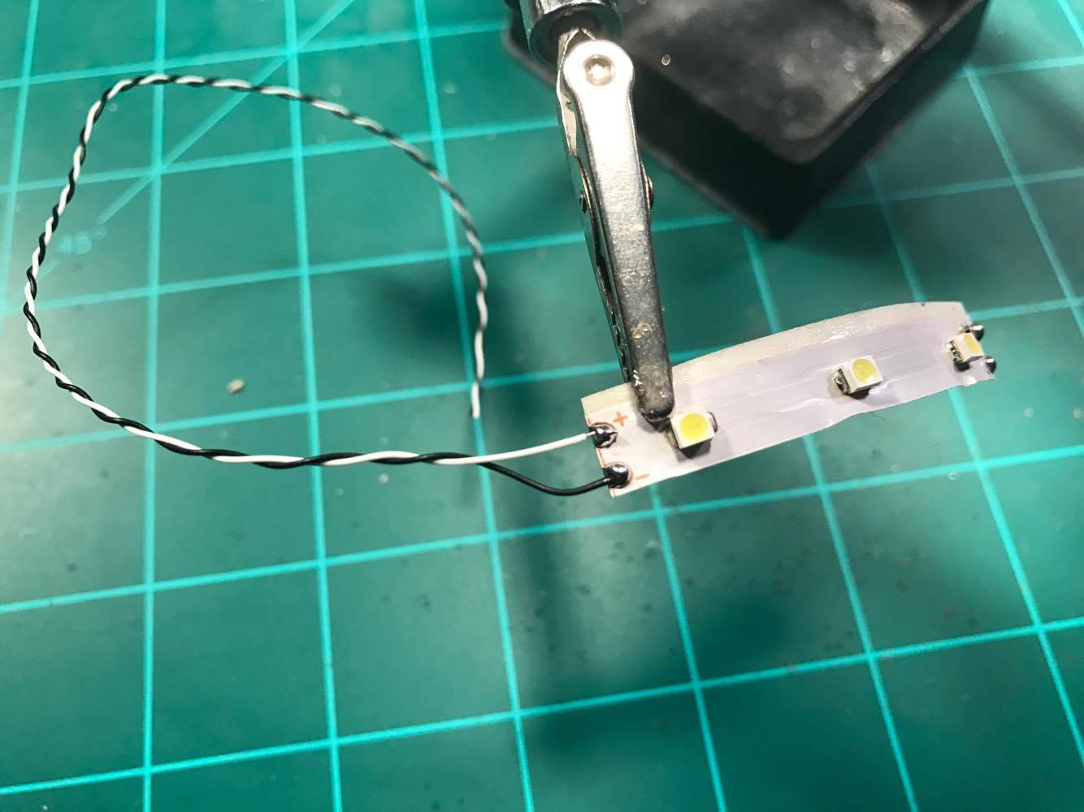
Next, strip off only about a half a millimeter of wire to attach to the points. Simply touch the iron tip to the solder point to re-melt the solder and slip the exposed wire into it and remove the iron, holding the wire still a second or two until the solder hardens. Repeat the process for both positive and negative contact points. That’s it! It’s wired!

Wiring tips and tricks
“How do those pro and advanced builders get such tidy wires without a rat’s nest?” We hear this question a lot. The trick is learning to be efficient with your wiring. It’s also important to understand current, voltage, and terms such as “common ground,” “common positive (hot),” and other terms and concepts such as voltage drop. For our purposes, we’ll focus on “common” connections. This concept basically uses the idea that you can connect either a positive or negative leg of one LED (with proper resistors) to another one on the same wire and terminal and they’ll share the terminal’s function. For the Tier2V2/Tier2V2 SFX B kit, most of the effects terminals are negative. (you’ll connect the negative wire of the LED’s to this terminal to get the effect and the positive to the 12V terminal) This means that, while different LED’s in one section may all be on separate effects, they can share one common 12V positive wire. This means, if you plan out your wiring carefully, almost all the LED’s in, say, your saucer section can have one positive wire spliced from each LED and strip to the next with only a single positive wire having to go back into the 12V terminal instead of all of the positive wires from each LED. Talk about a space saver!
The negative wires will each go to their respective effects terminal. But you can share the wires from each effect as well if multiple LED’s have the same effect. (for example, each NAV light can share one negative wire) Then you can do the same for shared strobe (STR) lights, for instance.
To achieve this “common” wiring, you will need to learn how to make a “splice” and a “pigtail” with your wires. A splice is simply twisting two exposed sections of wire together and soldering them together. You can also twist the two wires together, then around an LED or resistor leg to have two wires attached to that leg, one that can go back to the terminal and the other to the next LED or strip. (NOTE: Each LED will still get its own resistor!) That basically makes it where the two wires are joined together to become one common wire. You’d simply connect the positives of each splice to the next LED positive leg and splice another there to go to the next.
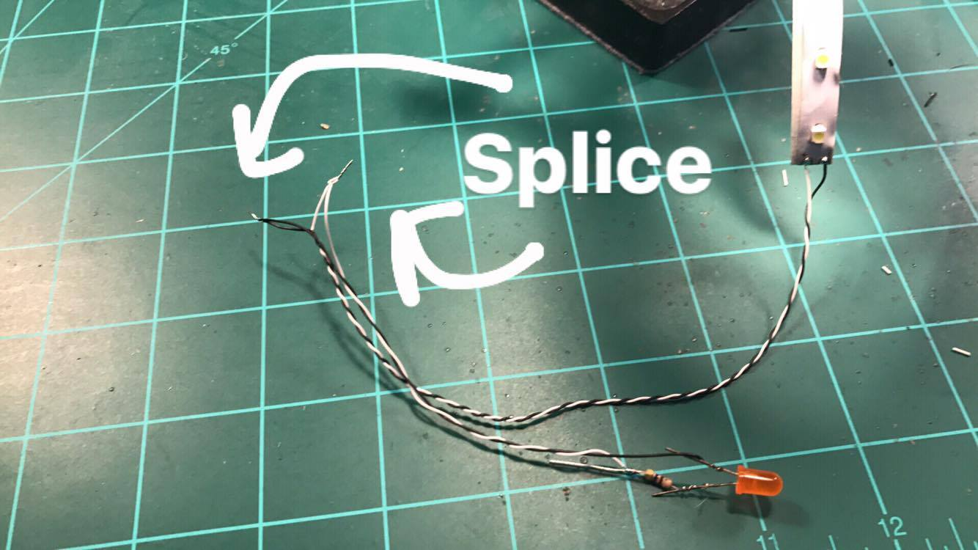
A “pigtail” is similar to a splice except, in this case, we’ll twist multiple (common positive, for example) wires together from several LED’s with one additional wire attached to go back to the terminal. That way, instead of trying to fit 10 wires into one terminal, you can simply have one. You will likely want to cover up the splice point of the pigtail with electrical tape or shrink tubing to avoid any possibility of crossing other wires and causing a short.
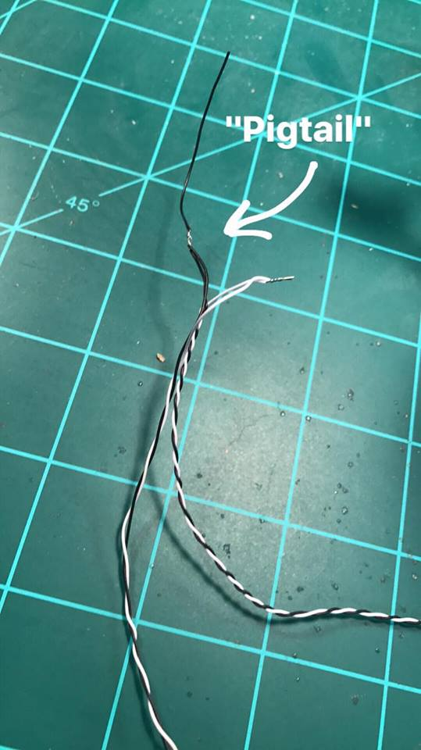
One more trick is using LED strips as a contact point for other LED’s. (as long as either the positive or negative wires or both connect to the same voltage and effects terminal) In the picture below, you can see where an LED has been attached to the LED strip on the contact points opposite of the wire end. The attached LED will behave with the same effect and button functions as the LED strip it’s attached to.
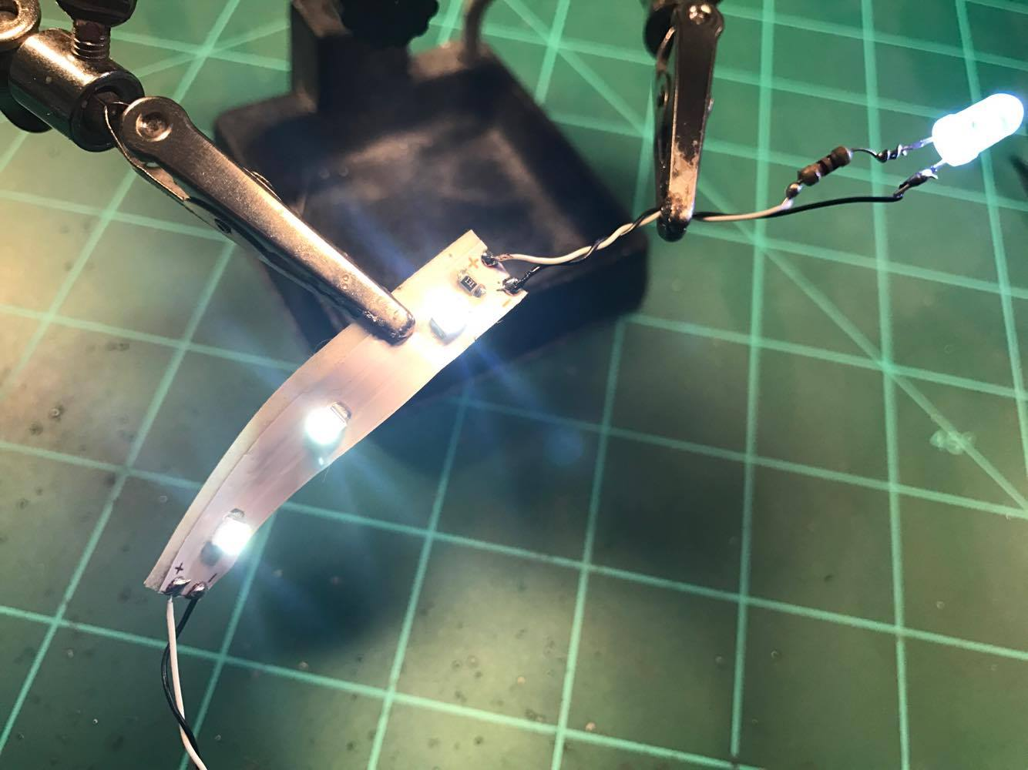
We hope some of these tricks make sense and help you with your wiring to keep things neat and tidy! Feel free to practice with spare LED’s and strips, if you have some. The more you do these steps, the easier it gets!

Board Layout
To begin, let’s have a look at the board layout. The diagram below should line up with your BEMS Commander Series Sovereign Effects Board. The terminals each have an effect assigned to them and your LED’s will and switches will connect using the screw terminals by simply inserting the stripped wire into the terminal and then tightening the screw down in place to secure the wire in the terminal. You may find it best to make a hook with the end of the wire when inserting it into the terminal so that it’s “double thick.” That will help the terminal have more to secure to. Also note that the polarity of the output terminal will be different for some effects.
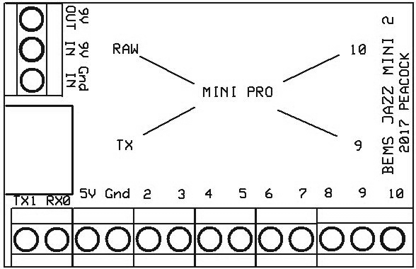

2009 ENTERPRISE Commander Series Terminals
TERMINAL | EFFECT | POLARITY/CONNECTION
3 | SWITCH BUSSARD SPEED | SWITCH WIRE 1 HERE  SWITCH WIRE 2 to GR
4 | BUSSARD PROGRAM | ORANGE WIRE FROM BUSSARD RINGS HERE
5 | SAUCER DOUBLE STROBE | NEGATIVE to LED
6 | BELLY/HANGAR NAV | NEGATIVE to LED
7 | NACELLE AFT STROBE | NEGATIVE to LED
9 | PYLON TRIPLE STROBE LIGHTS | NEGATIVE to LED
10 | IMPULSE ENGINES | NEGATIVE to LED

Board Layout Description

3 - BUSSARD SPEED CONTROL SWITCH – This terminal controls the switch for the bussard speed control. In connecting this switch, you can choose the speed of the rotation of the LED’s in the bussard caps. There are 5 speeds. The default speed is middle speed (3) and is the speed that automatically comes on when the board is powered up. If you do not want to change the speeds, you can simply leave the switch disconnected and the speed will always come on at the default speed. To connect this switch, connect one pole on the switch to this terminal and the other to GR.
4 – BUSSARD NEOPIXEL PROGRAM – This terminal controls the program for the bussard NeoPixel Rings. There are four wires from the bussard rings. The ORANGE wire will connect to this terminal. More information on the bussard NeoPixel ring connection follows in a later section.
5 – SAUCER NAV DOUBLE STROBE – This terminal controls the double strobe navigation lights positioned on the saucer. Connect the NEGATIVE leg of your strobe LED’s to this terminal. The POSITIVE (with proper resistor) leg of the LED’s will connect to 9V.
6 – BELLY/HANGAR NAVIGATION - This terminal navigation lights on the belly of the ship and above the hangar. Connect the NEGATIVE leg of your strobe LED’s to this terminal. The POSITIVE (with proper resistor) leg of the LED’s will connect to 9V.
7 – NACELLE STROBES - This terminal controls the strobe lights on the top/rear of the nacelles. Connect the NEGATIVE leg of your strobe LED’s to this terminal. The POSITIVE (with proper resistor) leg of the LED’s will connect to 9V.
9 – PYLON TRIPLE STROBE - This terminal controls the faster strobes lights at the back side of the pylons. You can use one LED for all three lights by drilling three tiny holes with a pin vise. You can also use fiber optic wire to even out the lights here, if you have some available. Refer to the YouTube “2009 Star Trek Ships Only” video or the movie for location reference. Connect the NEGATIVE leg of your strobe LED’s to this terminal. The POSITIVE (with proper resistor) leg of the LED’s will connect to 9V.
10 – IMPULSE ENGINE – (do not use if using the Captain Series Upgrade) This terminal controls the basic impulse engine effect. Connect the NEGATIVE leg of your impulse LED’s (with proper resistor) to this terminal. The POSITIVE leg of the impulse LED’s will connect to 9V. NOTE: If you are using the Captain Series Upgrade, you will use the Impulse Engine terminal on that board INSTEAD of this terminal.

2009 ENTERPRISE BUSSARD NEOPIXEL RINGS
To connect the bussard NeoPixel Rings, find the wires coming off the rings. Note that the starboard ring has 4 wires and the port ring has only three. Begin by running all of the wires to the central point in the secondary hull. You can then twist and solder the wires together by color. (except the single orange wire) The RED wires will connect to the board’s VC terminal. DO NOT connect it to 9V or you will damage the rings! Connect the BLACK wires to GR on the main board. Connect the ORANGE wire (only one of these) to TERMINAL 4 on the main board as shown above. Finally, leave the YELLOW wires twisted and soldered together, but cap them off with electrical tape or a small wire nut or other shielding method that will keep them connected, but protected from shorts or connections with other wires or lights. The YELLOW wires DO NOT connect to the board at all, only to one another.

2009 ENTERPRISE NACELLE STRIPS
To connect the blue LED strips for the nacelle chillers and for the forward deflector, (if using strips for the deflector) simply connect the POSITIVE wire to 9V and the NEGATIVE wire to GR. If you’re using single LED’s for the forward deflector, make sure you use the proper resistor. NOTE: If you are using the Captain Series Upgrade, (sold separately) do not connect the nacelle strips to this Commander Board as they will connect to the warp effect terminal on that board.

For any questions, contact us anytime through our Facebook page or at: www.bigeasymodelingsolutions.com
Thank you and happy modeling!!!

